**Scientific calculator with menu driven code and a gui using tkinter**

**18IT220 - PROBLEM SOLVING USING COMPUTERS**

*Submitted by*

***Yajith Vishwa.S***

***18IT116***

***and***

***Dhivya Ranjani.P***

***18IT021***

*Guided by*

***Mr.C.Jeyamala***

*Assistant Professor*

*Department of Information Technology.*



***Department of Information Technology***

**THIAGARAJAR COLLEGE OF ENGINEERING**

(An Autonomous Institution Affiliated To Anna University)

**MADURAI – 625 015**

***May 2019***

###### **THIAGARAJAR COLLEGE OF ENGINEERING**

**(An Autonomous Institution Affiliated to Anna University)**

**MADURAI – 625 015.**

**Aim:**

To develop a scientific calculator using python.

**Theory:**

The scientific calculator will help the engineering to solve the easy problems. A scientific calculator is a type of [electronic](https://en.wikipedia.org/wiki/Electronics) [calculator](https://en.wikipedia.org/wiki/Calculator), usually but not always handheld, designed to calculate problems in [science](https://en.wikipedia.org/wiki/Science), [engineering](https://en.wikipedia.org/wiki/Engineering), and [mathematics](https://en.wikipedia.org/wiki/Mathematics). They have almost completely replaced [slide rules](https://en.wikipedia.org/wiki/Slide_rule) in traditional applications, and are widely used in both education and professional settings.

In certain contexts such as higher education, scientific calculators have been superseded by [graphing calculators](https://en.wikipedia.org/wiki/Graphing_calculator), which offer a superset of scientific calculator functionality along with the ability to graph input data and write and store programs for the device.

**Code**:

def switch(n):

if(n=="1"):

arthematic()

elif(n=="2"):

logical()

elif(n=="3"):

comparison()

elif(n=="4"):

bitwise()

elif(n=="5"):

trignomentry()

elif(n=="6"):

factorial()

elif(n=="7"):

factor()

def arthematic():

l=[]

print("\nEnter the value with spaces")

l=[int(x) for x in input().split()]

n=input("\n1.add,2.sub,3.mul,4.div,5.expo,6.floor,7.Square root")

if(n=="1"):

g=0

for i in range(len(l)):

g+=l[i]

print("\nSum of ",l,"is",g)

elif(n=="2"):

g=0

for i in range(len(l)):

g+=l[i]

print("Difference of ",l,"is",g)

elif(n=="3"):

g=0

for i in range(len(l)):

g*=l[i]

print("Product of ",l,"is",g)

elif(n=="4"):

g=0

for i in range(len(l)):

g/=l[i]

print("Divisor of ",l,"is",g)

elif(n=="5"):

g=l[0]

for i in range(len(l)):

g**=l[i]

print("Exponent of ",l,"is",g)

elif(n=="6"):

g=0

for i in range(len(l)):

g//=l[i]

print("Floor divison of ",l,"is",g)

elif(n=="7"):

import math

a=int(input("\nValue for finding square root"))

print("Square root of",a,"is",math.sqrt(a))

else:

print("Invalid input,Run the program again")

def logical():

x=input("\n1.True or 2.False")

y=input("\n1.True or 2.False")

if(x=="1")and(y=="1"):

x=True

y=x

elif(x=="0")and(y=="0"):

x=False

y=x

elif(x=="1"):

x=True

elif(y=="1"):

y=True

elif(x=="0"):

x=False

else:

y=False

print("x and y is",x and y)

print("x or y is",x or y)

print("not x is",not x)

print("not y is",not y)

def comparison():

l=[]

g=0

ls=0

e=0

n=0

print("\nEnter the values")

l=[int(x) for x in input().split()]

for i in range(len(l)):

g=(g>l[i])

n=(n!=l[i])

ls=(ls<l[i])

e=(e==l[i])

print("Less than",ls)

print("Greater than",g)

print("Equal to",e)

print("Not equal to",n)

def bitwise():

x=int(input("\nEnter the value in binary"))

y=int(input("\nEnter the value in binary"))

print("&",x&y)

print("|",x|y)

print("-",x-y)

print(">>",x>>y)

print("<<",x<<y)

def trignomentry():

import math

a=int(input("\nEnter the value"))

print("sin",math.sin(a))

print("cos",math.cos(a))

print("tan",math.tan(a))

d=input("\nDo you want to find hypotenuse?")

if(d=="yes")or(d=="Yes")or(d=="YES"):

b,c=input("Enter the value of a and b").split()

b=int(b)

c=int(c)

print(math.hypot(b,c))

print("\nRadian",math.radians(a))

def factorial():

n=int(input("\nEnter the value to find the factorial"))

l=[0,1]

for i in range(n+1):

s=l[i]+l[i+1]

l.append(s)

print("The factorial is")

print(l,end=" ")

def factor():

x=int(input("\nEnter the value for factor"))

print("The factors of",x,"are:")

for i in range(1, x + 1):

if (x % i == 0):

print(i)

print("\nEnter the number")

n=input("\n1.arthematic,2.logical,3.comparison.4.Bitwise,5.Trignomentry,6.Factorial,7.Factors")

switch(n)

**Output:**

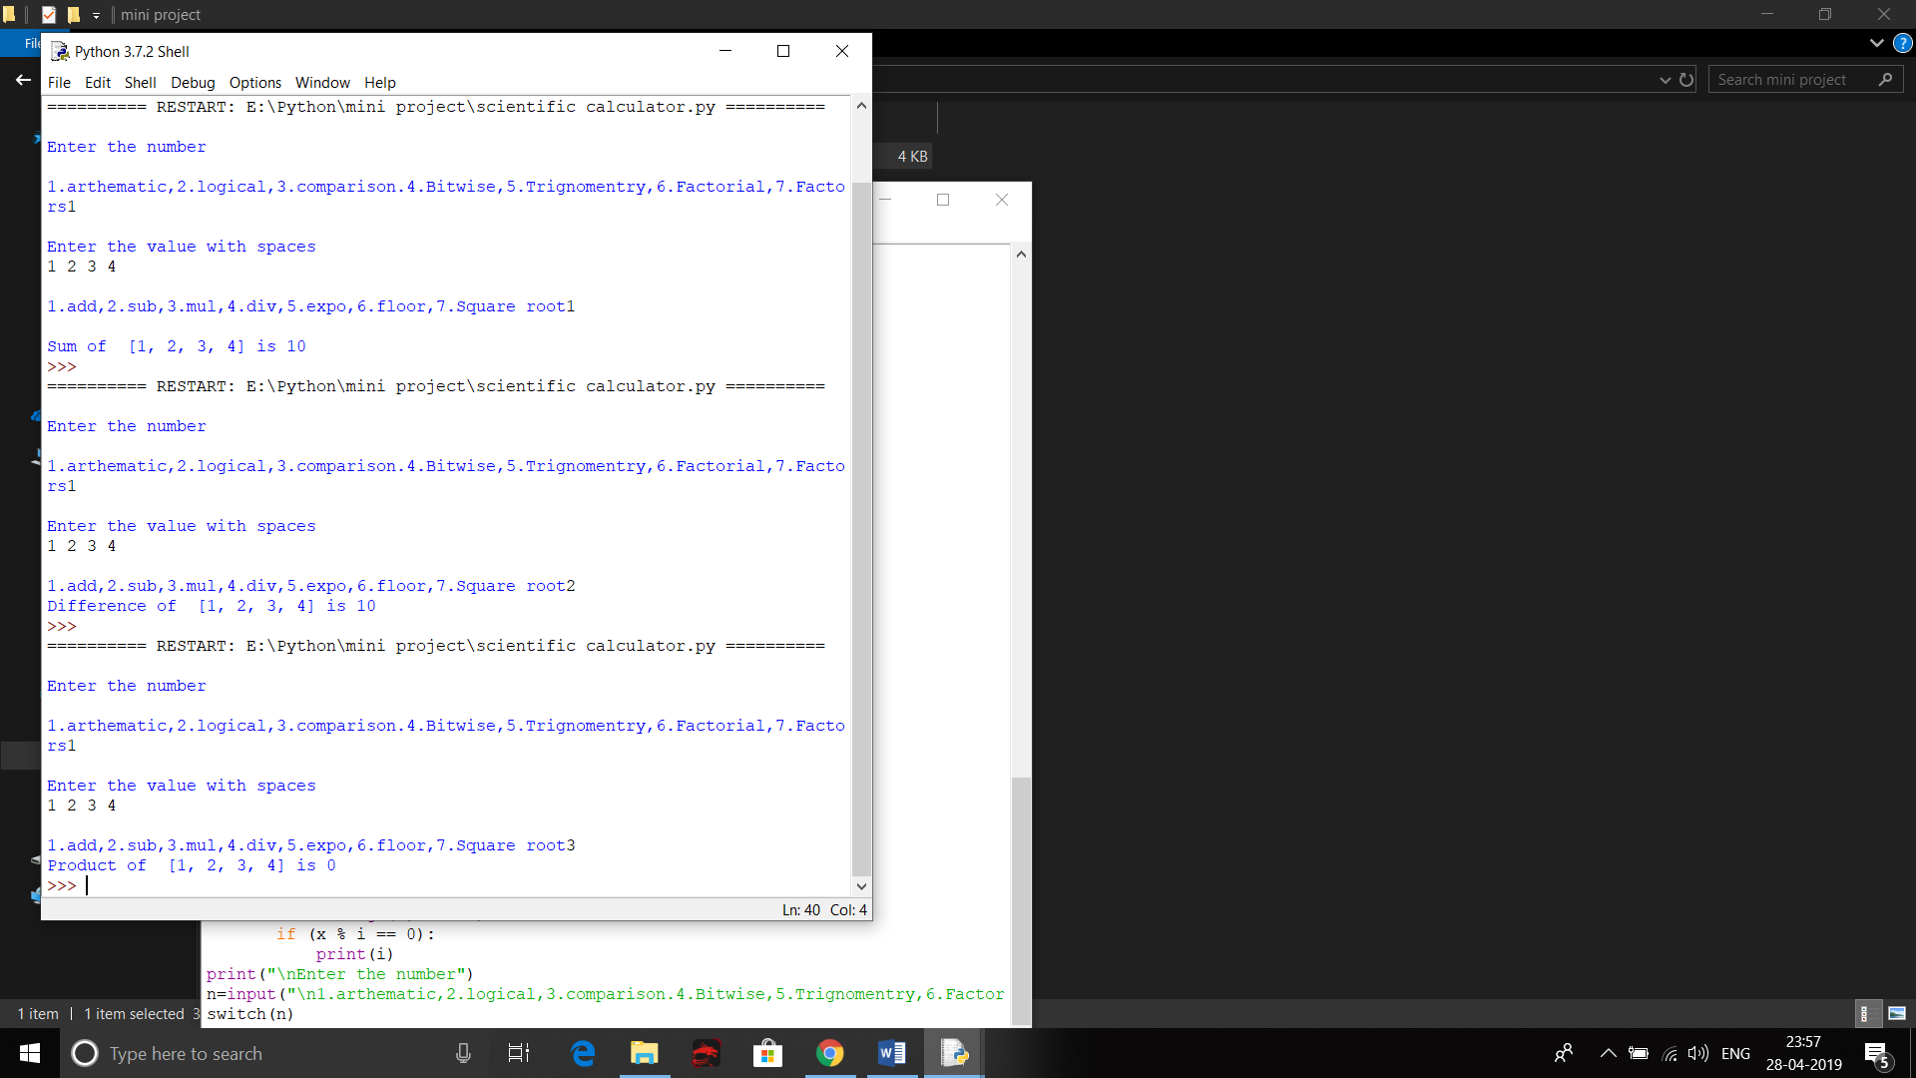

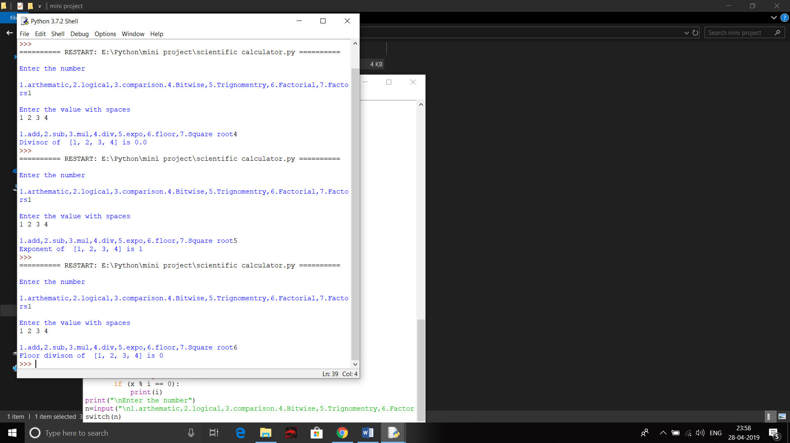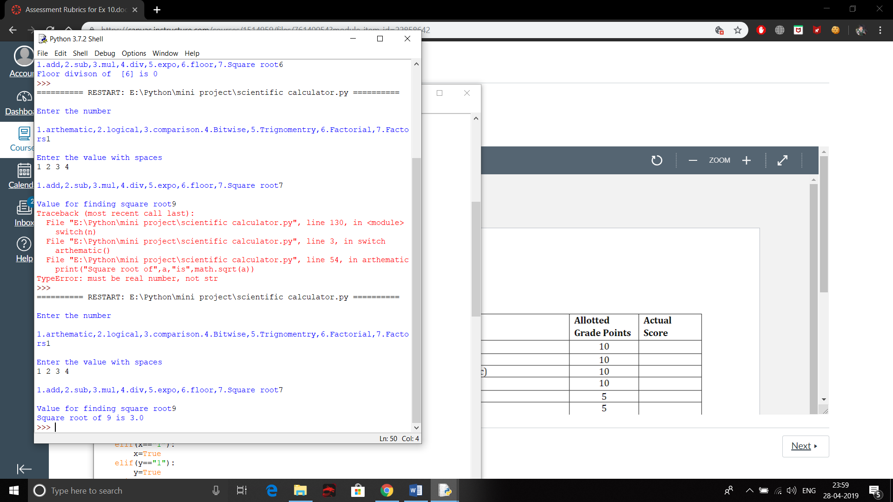

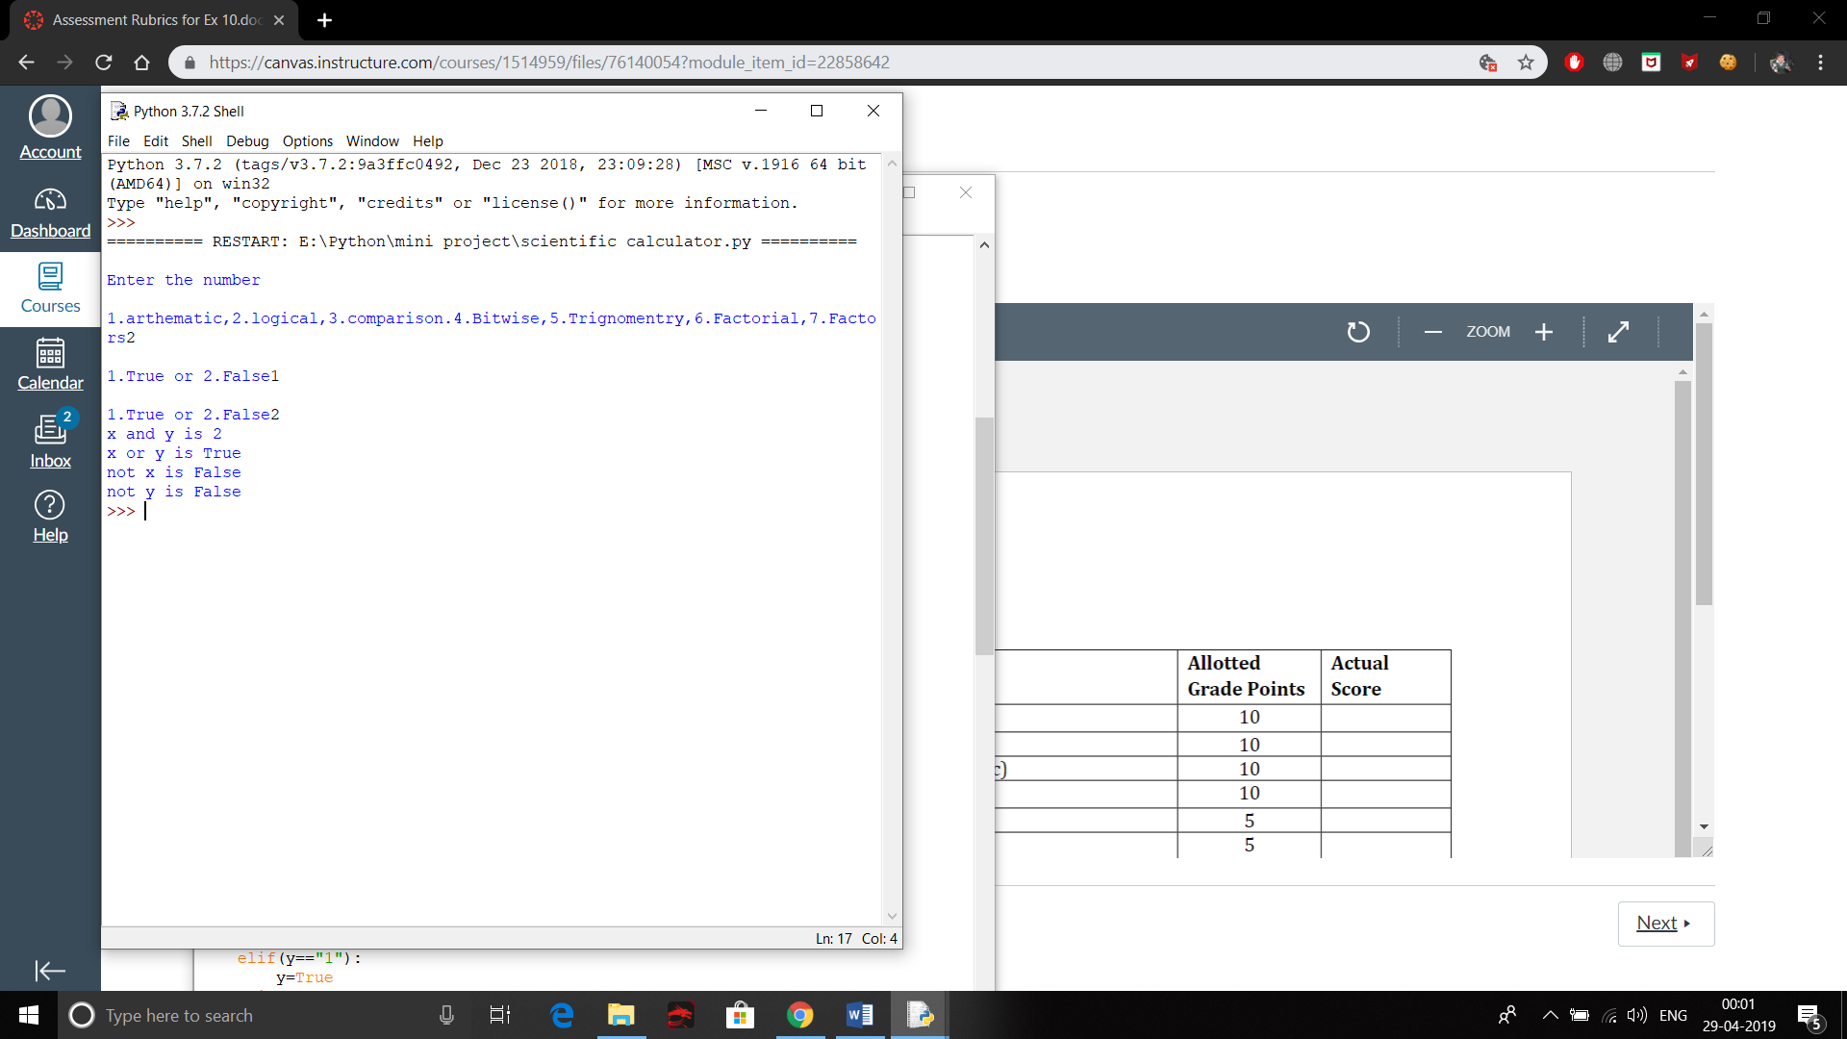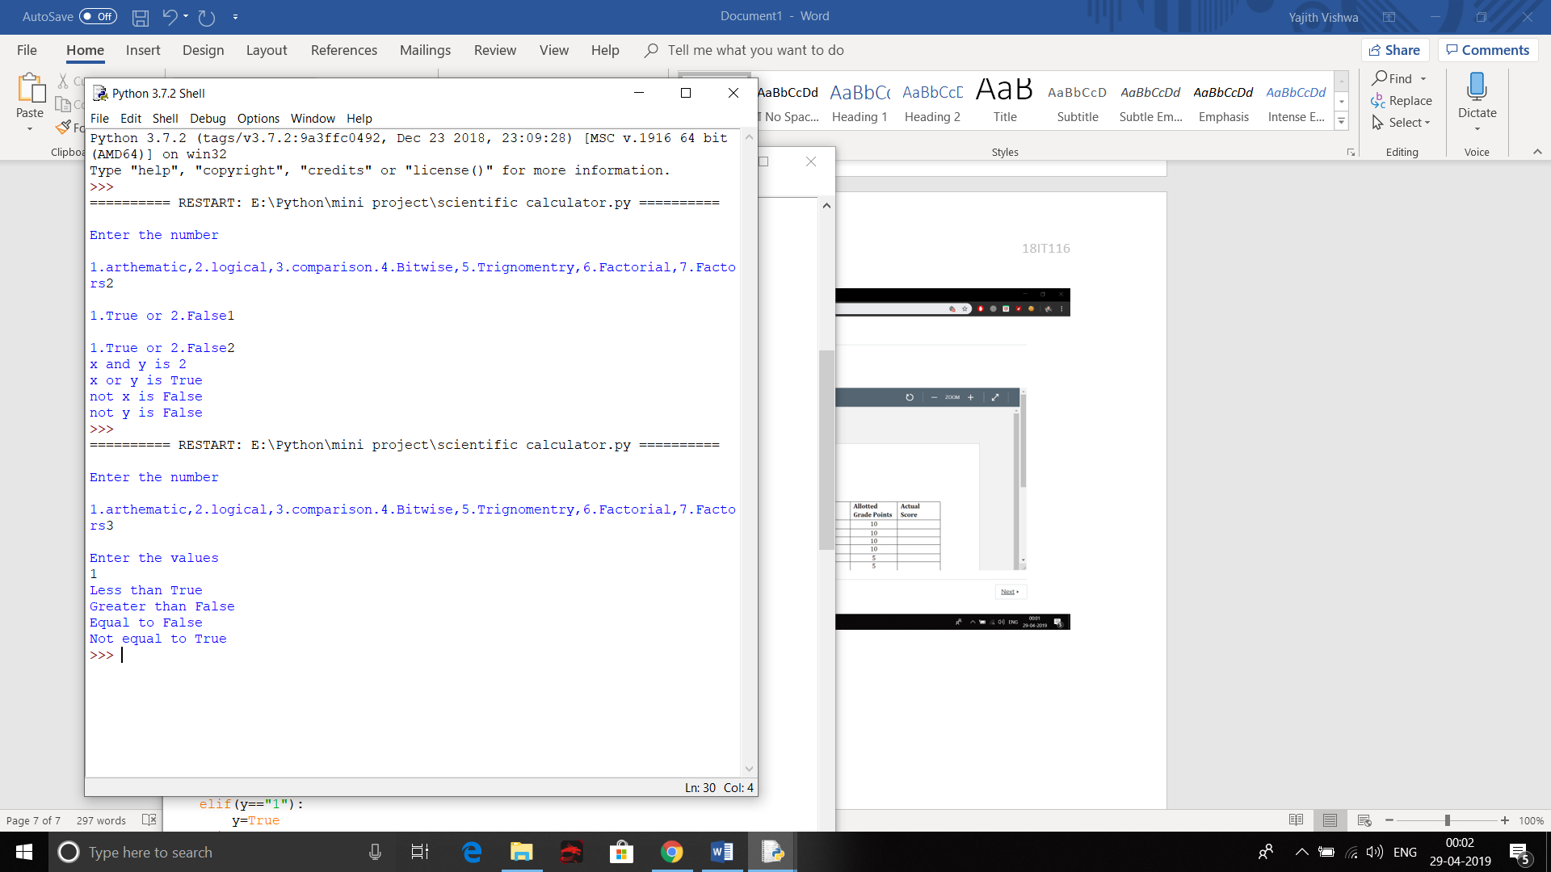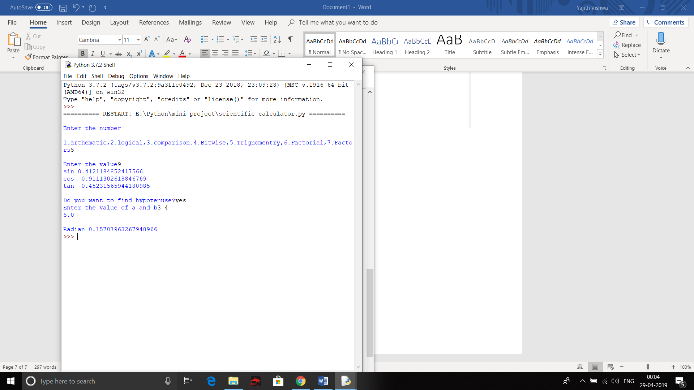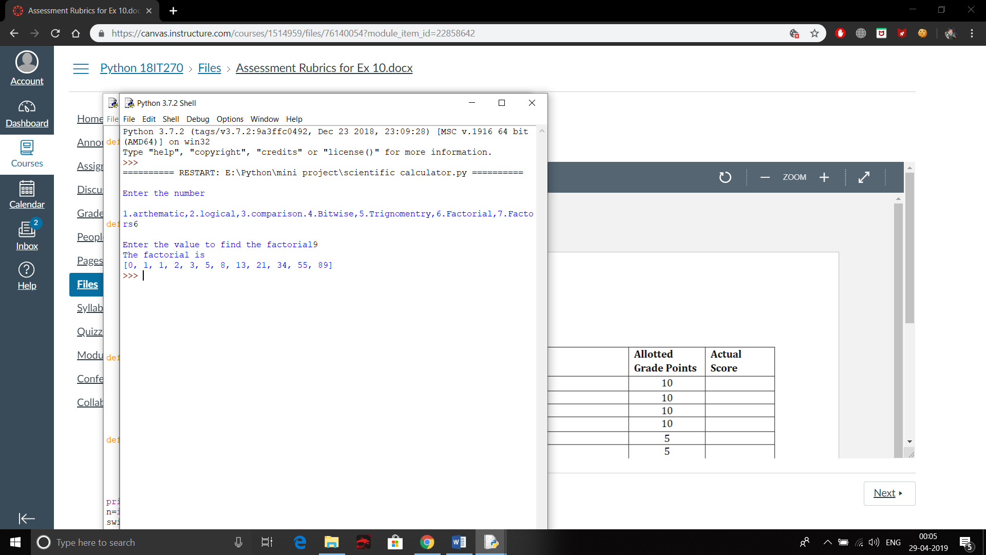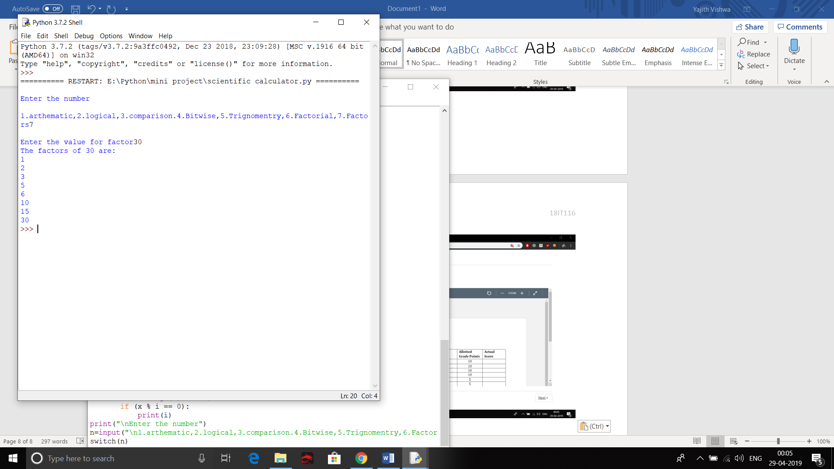

**GUI CALCULATOR:**

**Theory:**

To create a tkinter :

1. Importing the module – tkinter
2. Create the main window (container)
3. Add any number of widgets to the main window
4. Apply the event Trigger on the widgets.

**Code:**

from tkinter import *

expression = ""

def press(num):

    global expression

    expression = expression + str(num)

    equation.set(expression)

def equalpress():

    try:

        global expression

        total = str(eval(expression))

        equation.set(total)

        expression = ""

    except:

        equation.set(" error ")

        expression = ""

def clear():

    global expression

    expression = ""

    equation.set("")

  if __name__ == "__main__":

    gui = Tk()

    gui.configure(background="light green")

    gui.title("Simple Calculator")

    gui.geometry("265x125")

    equation = StringVar()

    expression_field = Entry(gui, textvariable=equation)

    expression_field.grid(columnspan=4, ipadx=70)

    equation.set('enter your expression')

    button1 = Button(gui, text=' 1 ', fg='black', bg='red',

                     command=lambda: press(1), height=1, width=7)

    button1.grid(row=2, column=0)

    button2 = Button(gui, text=' 2 ', fg='black', bg='red',

                     command=lambda: press(2), height=1, width=7)

    button2.grid(row=2, column=1)

    button3 = Button(gui, text=' 3 ', fg='black', bg='red',

                     command=lambda: press(3), height=1, width=7)

    button3.grid(row=2, column=2)

    button4 = Button(gui, text=' 4 ', fg='black', bg='red',

                     command=lambda: press(4), height=1, width=7)

    button4.grid(row=3, column=0)

    button5 = Button(gui, text=' 5 ', fg='black', bg='red',

                     command=lambda: press(5), height=1, width=7)

    button5.grid(row=3, column=1)

    button6 = Button(gui, text=' 6 ', fg='black', bg='red',

                     command=lambda: press(6), height=1, width=7)

    button6.grid(row=3, column=2)

    button7 = Button(gui, text=' 7 ', fg='black', bg='red',

                     command=lambda: press(7), height=1, width=7)

    button7.grid(row=4, column=0)

    button8 = Button(gui, text=' 8 ', fg='black', bg='red',

                     command=lambda: press(8), height=1, width=7)

    button8.grid(row=4, column=1)

    button9 = Button(gui, text=' 9 ', fg='black', bg='red',

                     command=lambda: press(9), height=1, width=7)

    button9.grid(row=4, column=2)

    button0 = Button(gui, text=' 0 ', fg='black', bg='red',

                     command=lambda: press(0), height=1, width=7)

    button0.grid(row=5, column=0)

    plus = Button(gui, text=' + ', fg='black', bg='red',

                  command=lambda: press("+"), height=1, width=7)

    plus.grid(row=2, column=3)

    minus = Button(gui, text=' - ', fg='black', bg='red',

                   command=lambda: press("-"), height=1, width=7)

    minus.grid(row=3, column=3)

    multiply = Button(gui, text=' * ', fg='black', bg='red',

                      command=lambda: press("*"), height=1, width=7)

    multiply.grid(row=4, column=3)

    divide = Button(gui, text=' / ', fg='black', bg='red',

                 command=lambda: press("/"), height=1, width=7)

    divide.grid(row=5, column=3)

    equal = Button(gui, text=' = ', fg='black', bg='red',

                   command=equalpress, height=1, width=7)

    equal.grid(row=5, column=2)

    clear = Button(gui, text='Clear', fg='black', bg='red',

                   command=clear, height=1, width=7)

    clear.grid(row=5, column='1')

    gui.mainloop()

**Output:**







**Result:**

The different calculation are done using with scientific calculator and a gui calculator is created using tkinter.